FOREST GARDEN FARMING FOR PEOPLE AND THE PLANET
BIANNUAL REPORT January-December 2025

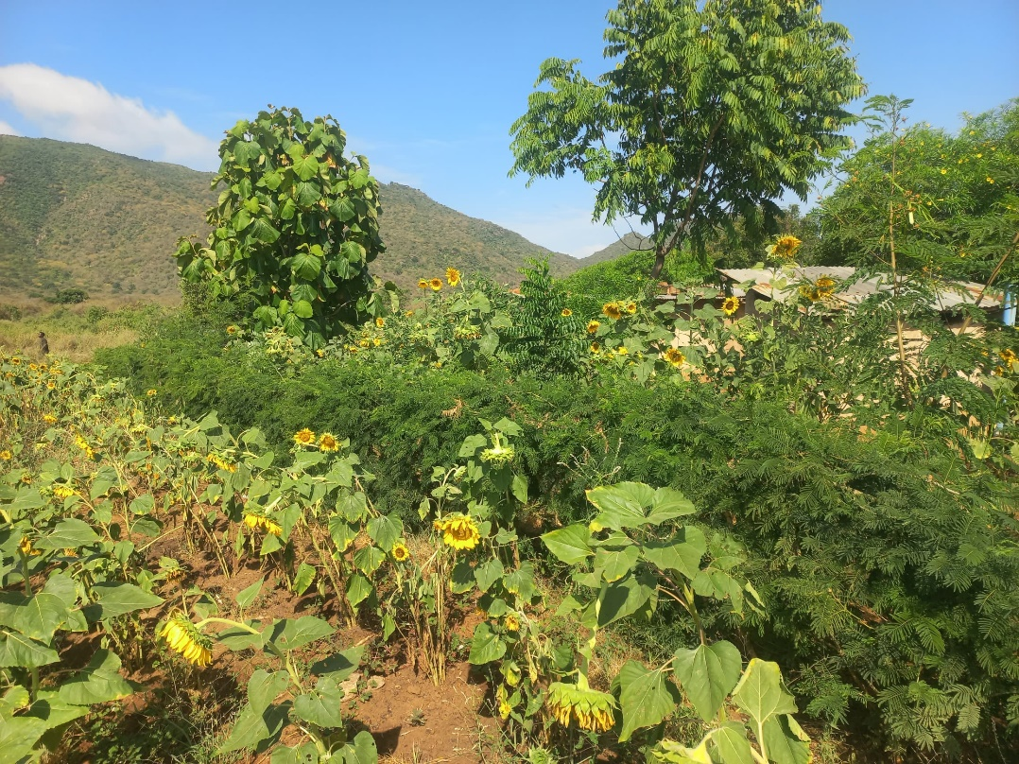 | 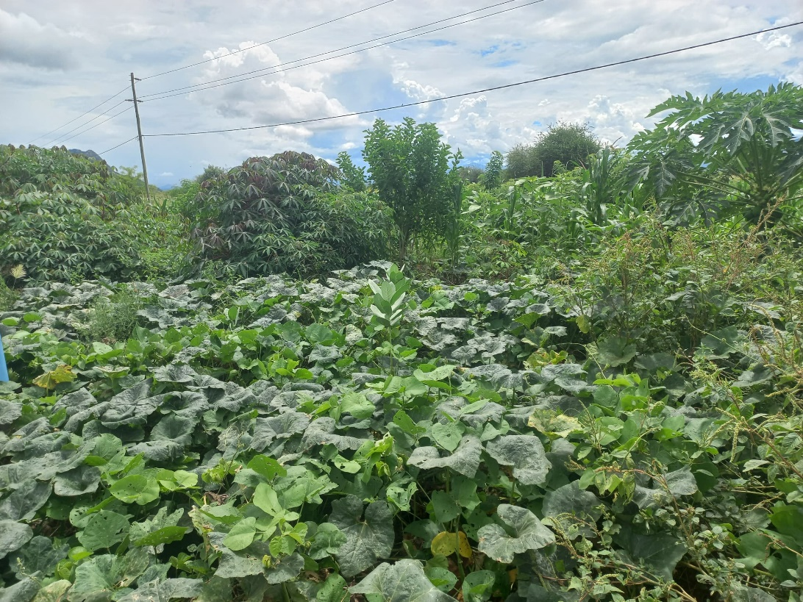
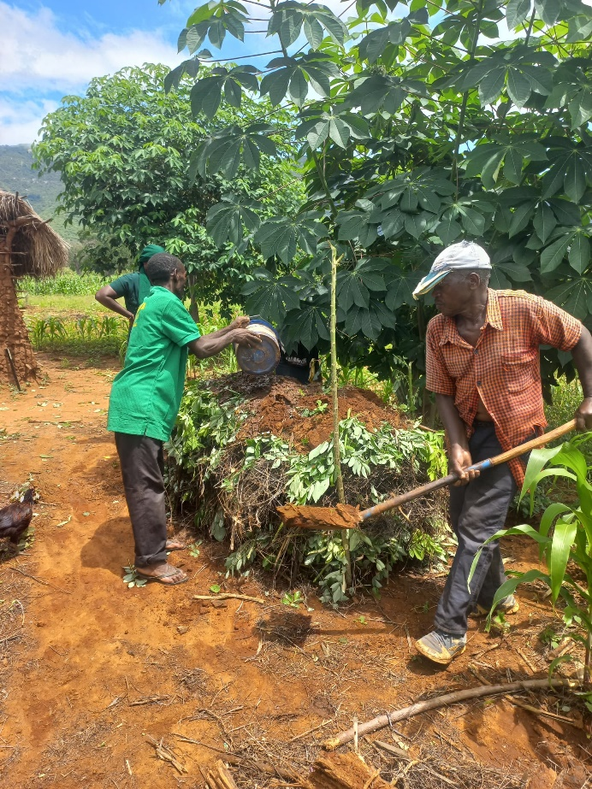 | 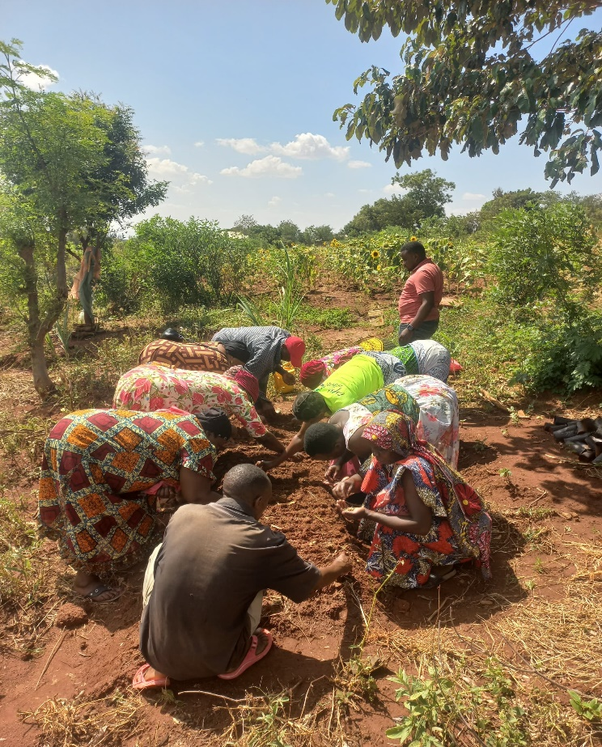

Contents
Aim of the report 2
Background information 2
Project outcomes 3
Outcome 1. Increased diversity of nutrient-rich foods throughout the year 3
Papaya: 3
Other fruit trees: Passion Fruit, lemon, mango and avocado 3
Guava: 4
Cassava: 5
Sweet Potatoes: 5
Pigeon peas: 5
Vegetable growing: 6
Water tanks for Ngulu, Kwakoa and Kwanyange groups 8
Outcome 2: Diverse farm products provide more to sell 9
Outcome 3: Improved landscapes by increased trees, better soils and improved water cycle 9
Hands on farmer training on raised beds nursery techniques for Live Fencing 9
Other tree species 11
Training on organic compost making using Gliricidia, Leucenae, Pigeon pea branches and farm residues. 12
Outcome 4: Farmers are more knowledgeable, enthusiastic and socially empowered 13
Accumulative list of all main trainings: 13
Participatory mapping and tree planting layout training for Forest Gardens 14
Outcome 5: Local NGOs capacity has been built in FGs approach and communications 15
Project outputs 16
Output 1: Government officers and villagers engaged 16
Output 2: New version: Forest Garden groups functioning (as many groups as needed to reach the minimum target number of farmers, 350) 17
Output 3: New version: Representative of each group, and minimum of 4 extension officers trained 17
Output 4: New version: Members trained in selected training sites 18
Output 5: 360 individual farmers' Forest Gardens established 18
Output 6: 1080 Neighbouring farmers trained/recruited by group members 19
Output 7: Savings and Loans function started, Marketing Associations established 19
Output 8: Local NGOs have participated to raise its capacity in FGs 20
Other happenings and activities 20
Staff changes and Internship 20
KIWAMWAKU internal auditor visit 20
CRDB bank group account explanation 20
Financial Report of January to June, 2025 21

Aim of the report
This report documents all planned and implemented activities starting from January to 30th June 2025. It elaborates project outcome/objectives and specific activities which have been carried out in each objective within six months, with challenges and recommendations also documented.
Targeted project outcomes
- Increased diversity of nutrient-rich foods throughout the year.
        - Indicators: Diversity of food consumed, months of food sufficiency
- Diverse farm products provide more to sell.
  - Indicators: Number of farm product sold; Farmers report contribution of farm produce to household income
- Improved landscapes by increased trees, improved water cycle and microclimates.
  - Indicators: Area under trees and shrubs; number of species added; visible signs of erosion; farmers report on change in farm environment
- Farmers are more knowledgeable, enthusiastic and socially empowered and they have adequate employment and livelihood.
  - Indicators: Farmers report increased enthusiasm for farming; Farmers report benefits of working in a group
- Local NGOs have participated to raise their capacity in FGs.
  - Indicators: Requests to train and/or give seminars; increase capacity and function to communicate
Expected results outputs include:
- Output 1. Government officers and villagers engaged
- Output 2. Revised: Forest Garden groups functioning (as many groups as needed to reach the minimum target number of farmers, 350)
- Output 3. Revised: Representative of each group, and minimum of 4 extension officers trained
- Output 4. Revised: Members trained in selected training sites (group member’s farms as joint training sites for trainings)
- Output 5. Individual farmers forest gardens established
- Output 6. Savings and loans function started, marketing associations established
- Output 7. Local NGOs have participated to raise their capacity in FGs.

Background information
The "Forest Gardens for People and the Planet" project introduces the Forest Gardens (FG) Approach in Northern Tanzania, aiming to address challenges faced by small-scale farmers while promoting sustainability. Traditional farming methods yield low outputs, contributing to food insecurity, soil degradation, and limited economic opportunities. The Forest Garden for People and the Planet project is implemented in Mwanga district lowlands. It started from Kituri and Kifaru villages in year 2023 and expanded to Kwanyange, Kisangara, Ngulu and Kwakoa villages during second year 2024. Expansion to the latter villages added 314 new beneficiaries, 162 females and 152 males. In this report we call these two sets of groups and farmers as old groups or old farmers and new groups or new farmers.
The project offers a solution by establishing multi-layered agroforestry systems that mimic natural forests, enhancing biodiversity, food security, and resilience to environmental changes. The project targets marginalized groups from small scale farming, including women, youth, persons with disabilities and PLHAs.
By integrating trees, vines, herbs, perennial vegetables, shrubs, and other crops Forest Gardens provide diverse products and services, improve livelihoods, and mitigate climate change impacts. Through companion planting and indigenous tree species, FGs enhance soil fertility, water cycles, and landscape aesthetics. The project's objectives encompass sustainable livelihoods, environmental protection, and empowerment of marginalized communities, aligning with sectors such as agriculture, environmental protection, and women's equality.
The project is funded by the Ministry for Foreign Affairs of Finland and coordinated by Liana organization from Finland, partnering with Kiwamwaku Foundation, spanning four years from 2023 to 2026.

Project outcomes

Outcome 1. Increased diversity of nutrient-rich foods throughout the year
What activities have contributed towards this outcome?

Papaya:
In 2024, we had provided the new farmer groups, total of 314 farmers, with 137 packets of high yield MALKIA F1 papaya seeds, with each farmer planting 15 seeds in nursery bags and outplanting in April 2024. By April 2025, farmers are now achieving their first harvests for home consumption and selling to neighbors and local markets, enhancing diets and generating income. Some farmers reported earning up to 80,000 Tsh per harvest. However, some farmers facing water challenges experienced poor harvests due to a lack of irrigation during the dry season.
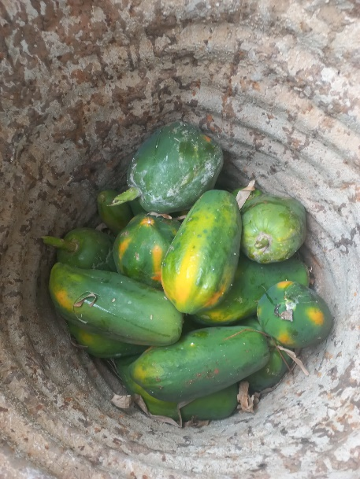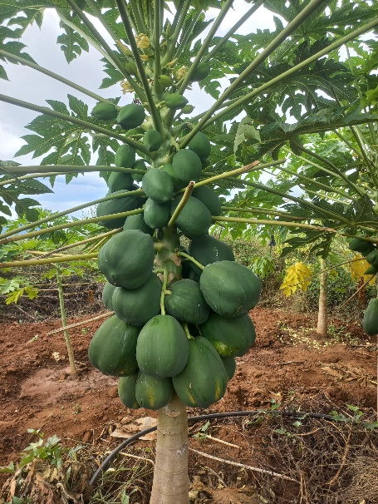
Figure 0-1. Malkia F1 papaya fruits and Papaya trees

Other fruit trees: Passion Fruit, lemon, mango and avocado
By May 2025, farmers who had planted passion fruit seedlings a year earlier began harvesting, using the harvest for juice making, and sales in local markets. Farmers who planted more seedlings reported higher yields, harvesting up to two 20 litter buckets per week and sold for 45,000Tsh, while those with fewer stems harvested about one 10 liter bucket per week during peak seasons.
Additionally, Kiruru Ibwaijewa group, which was for some reason left behind in 2024, received training on how to collect lemon, lime, and orange seeds locally and sow them in polythene bags.
Most farmers are also preparing mango and avocado seedlings based on their needs and farm sizes. These will be grafted during the cool season in July 2025 and then prepared for outplanting in the next rainy season. This strategy enhances household nutrition, creates new income opportunities, and strengthens the long term sustainability and productivity of farming activities.
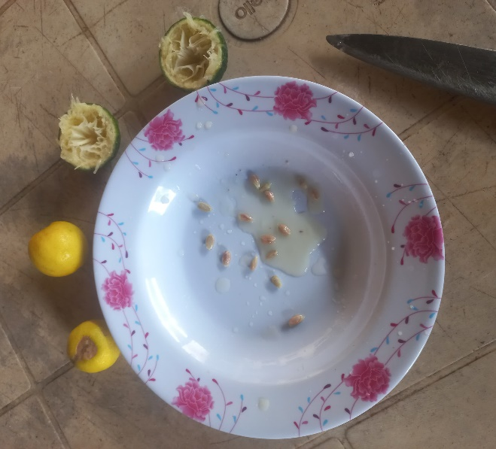 | 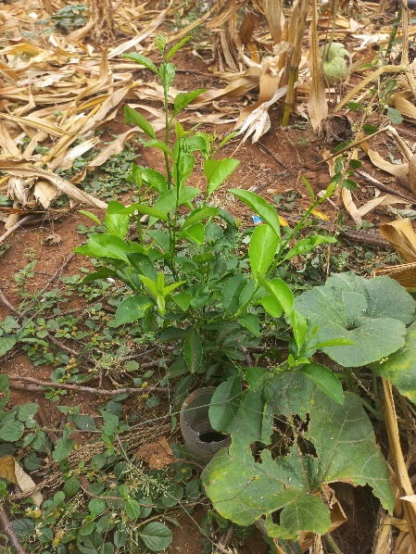
Figure 0-2. Lemon seeds collection and young lemon tree with bottle irrigation

Guava:
In April 2025 Kisangara, Kwanyange and Kiruru Ibwaijewa farmers sowed guava seeds, about one bucket of 10 litre, and grew about five seedlings each farmer, with a total of 1,500 seedlings to be planted October 2025 during short rain season.
The guava seedlings planted by farmers last year have shown good growth progress. Despite facing water challenges, farmers ensured their survival by watering them with buckets.
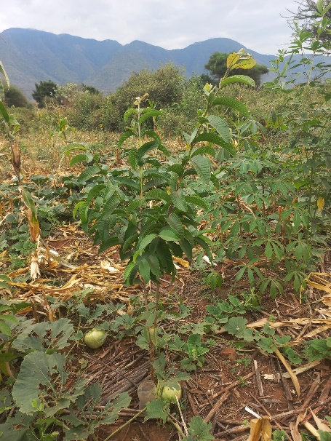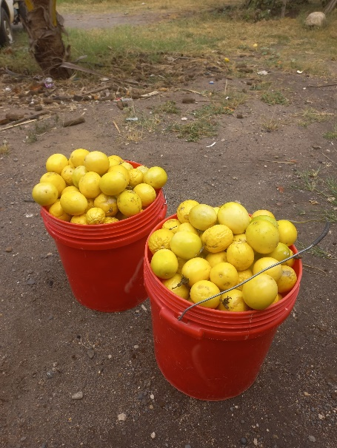
Figure 0-3. Young guava tree with bottle irrigation and passion fruits harvest

Cassava:
Cassava cuttings were procured from Lushoto in April 2024, and 369 farmers received 15 cuttings each. Due to the prolonged dry season, most cuttings dried up, leaving only 4 to 5 stems alive to some farmers in areas with water scarcity like Kwanyange, Kiruru, Ngulu and Kwakoa. By April 2025, some farmers reported harvesting a few cassava roots to eat with their families in Kifaru and Kituri, noting that the variety is delicious. Farmers were also trained to save planting material by replanting harvested stems to ensure future production.

Sweet Potatoes:
As the old groups had received their sweet potato vines in 2024, it was the new groups’ turn to receive theirs in 2025. Julius and Kimaro obtained the vines from Siha-Kilimanjaro in June. 314 farmers (new groups plus one youth from Kituri A) received two different varieties (original plan was four varieties but managed to get only two varieties), and after group trainings led by Julius, farmers implemented the planting independently.
A total of 100 bags weighing 100 kg, were purchased for 2,000,000tsh (plus 200,000 labour for cutting them, 120,000, 15,000 ropes sisal bags and 500,000 transportation), each farmer received about 50 to 80 vines. The harvest of fresh sweet potatoes expected to begin in mid-November
(Lesson contents were included in Section 2 2024).
During the first half of 2025, some of the harvested sweet potatoes by old farmers continued to serve as a source of food for home consumption. The orange-fleshed varieties, which are rich in vitamin A, played an essential role in addressing micronutrient deficiencies and improving health. This dual role of sweet potatoes as both a staple food and a nutritional resource underscores their importance in enhancing food security and promoting diet diversification among farming households. Old farmers reported that sweet potatoes are commonly consumed with tea or mixed with beans.
A major challenge observed was the widespread impact of waterlogging on many farms during short and long rains. This led to reduced yields and difficulties in preserving planting materials (vines) for the next season.
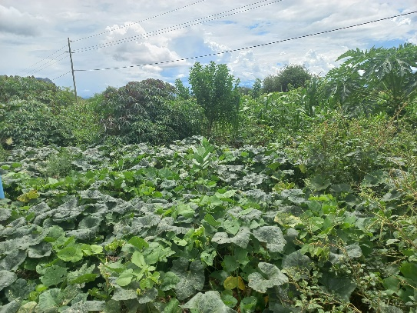 | 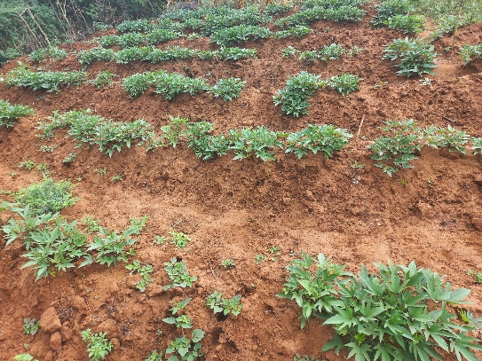

Figure 0-4. Cassava and sweat potatoes beds inside live fence

Pigeon peas:
Recognizing the nutritional value of protein, all new farmers had received one kilogram of pigeon peas each for planting during the long rains of 2024. One kilogramme was estimated to enable them to plant at least an acre using crop rotation and intercropping with maize. However, due to late procurement (pigeon peas should be purchased in June-July) insect damage was considerable (around 50%), thus each farmer received about half a kilogram of quality seeds. We used this challenge as an opportunity to train farmers on seed preservation techniques using ash, pepper, or neem seeds.
Despite insect attacks causing damage to many pods and seeds, by June 2025 farmers reported starting to harvest pigeon pea, served with ugali and enjoy it with their families. The largest production was observed after the rainy season in June 2025.
It is difficult to know exactly what variety we end up purchasing when we purchase from farmers in another area. The first ever time we purchase pigeion peas (2023), we got a very large and slow-maturing variety. This second set was, on the contrary, a quickly maturing and much smaller in size.
To support continued production, the project purchased an additional 160 kilograms of seeds (cost 720,000Tsh and transport 45,000Tsh) from Trees for the Future farmers in June 2025. These seeds will be distributed and planted during the upcoming short rains, as requested by farmers. We will experiment ways to preserve the seeds till then. Pigeon peas are very prone to insect attach. Without any deterrents, even whole harvest can be damaged.

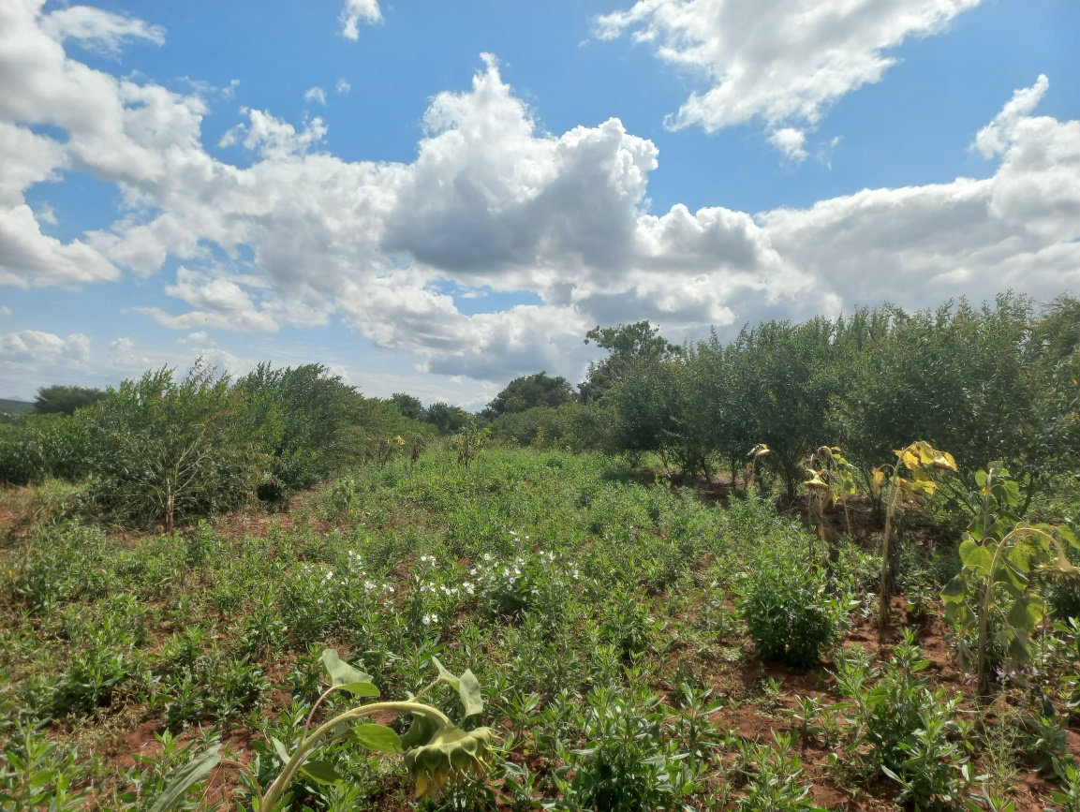 | 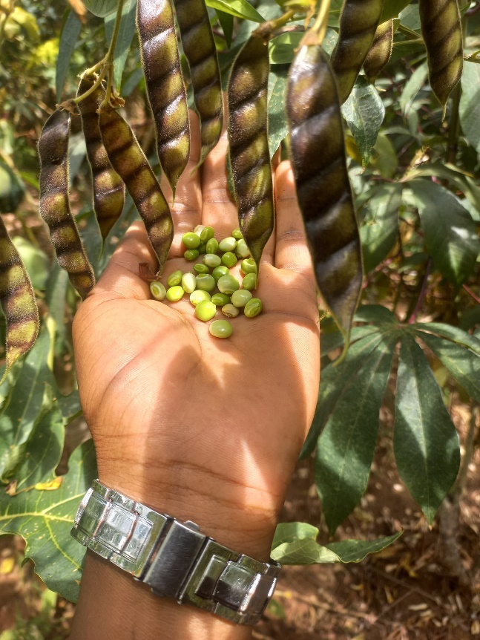
Figure 0-5. Health pigeon pea marejea with green pods and seeds ready for harvest

Vegetable growing:
June 2025 started the third season we support vegetable growing in groups. This is due to the difficulties face during the El Nino rains of November 2023 when the activity was first implemented with old groups. A total of 848,500Tsh was spent on purchasing a total of 11 vegetable varieties including collard, black nightshade, Chinese cabbage, spinach, Leshuu, eggplant, okra, onion, chili pepper, carrot, and field pumpkin. The selection of vegetable varieties was carefully tailored to the water availability in different areas and farmer suggestion. This approach aimed to maximize productivity while ensuring that farming practices remained sustainable and adapted to local environmental conditions.
The selection process was a collaborative effort between farmers and project staff, emphasizing participatory decision-making. Together, we discussed how various vegetable varieties respond to different water conditions, leveraging both scientific knowledge and farmers' experiences.
Following the discussions, a tailored selection of vegetable varieties was finalized for each area based on water availability. In water-scarce villages like Kwanyange and Ngulu Kwakoa, the chosen vegetables included collard, kale, black nightshade, okra, onion, and chili pepper, which are well-suited to thrive with minimal water. Meanwhile, for water-abundant villages such as Kisangara, Kituri, and Kitopeni, the selected crops included spinach, Leshuu, Chinese cabbage, eggplant, field pumpkin, carrot, onion, and chili pepper. This strategic selection ensures optimal productivity while addressing the specific water conditions of each region, fostering sustainable farming practices.
In early January 2025, Mkongea group farmers reported harvesting onions and distributed to each member, achieving a surplus that was enough to sustain them for three months.

Direct sowing or nurseries for pre-growing?
Okra, carrot, and field pumpkin were directly sown in the main field, while the remaining leafy vegetables and fruit vegetables, such as eggplant and chili pepper, were first started in the nursery. This approach ensured proper germination and growth conditions for each crop type before transplanting or direct cultivation.

Bed preparation
Two types of beds were used: raised beds measuring 1 meter by 10 meters for drip irrigation, where eggplant, onion, and chili pepper were planted, and sunken beds measuring 2 meters by 5 meters for manual irrigation using watering cans, which were dedicated to all leafy vegetables. This arrangement optimized water use and crop growth based on the irrigation method and crop requirements.

Vegetable production in groups and on individual farms
Vegetable production was organized into individual and group production. All old farmers and Kisangara groups now distribute seeds equally to ensure that every member plants individually at their home areas. Each farmer prepares at least three beds, allowing for crop rotation and intercropping with different vegetable varieties.

Before the June 2025 seed distributions, farmers learned a simple principle of crop rotation to avoid pests and soil depletion. As green vegetables use a lot of nitrogen from the soil, legumes should be planted after them. After legumes come root vegetable, followed by fruit vegetables, and back to leafy greens. This principle is easy for farmers to remember due to the ‘location’ of leaves and roots in the plant, and only one piece of information to remember: leafy greens use a lot of nitrogen. (see full lesson plan in Section 2)
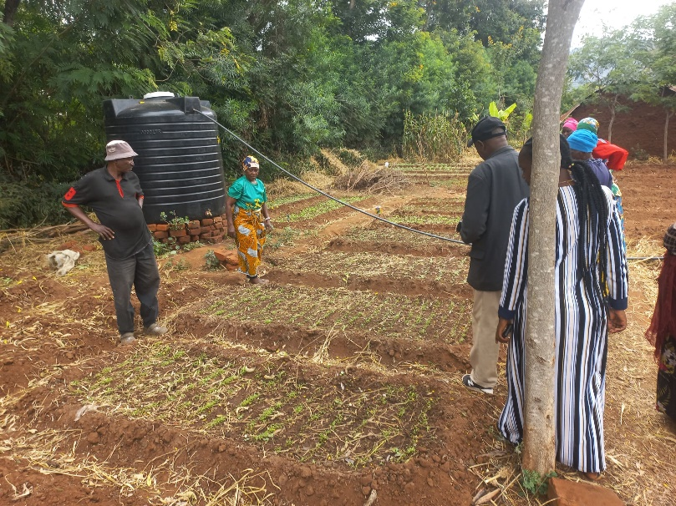 | 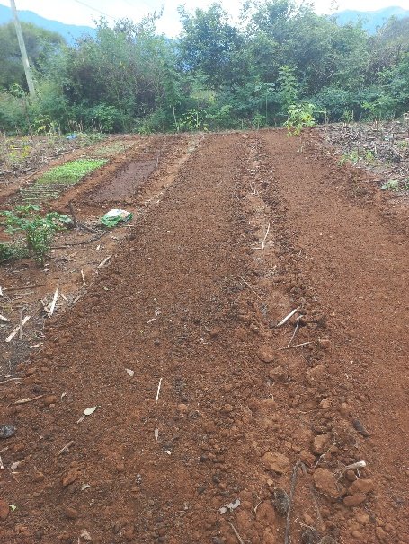
Figure 0-6. Vegetables germination and planting beds in group and individual production

Pest and disease control
In 2023 and 2024, one representative from each group, all field project staff, intern (Sarah) and extension officers received training in basic organic farming at SAT, which included pest and disease management. We used this knowledge in June 2025 to prepare a handout and to teach pest management using botanical pesticides like neem to control aphids, proper fertilization using compost, crop rotation, intercropping with onions and chili peppers, regular weeding, and selecting resistant vegetable varieties.

Water tanks for Ngulu, Kwakoa and Kwanyange groups
There are big differences between the project locations in water availability. In Kifaru and Kituri we had earlier assisted farmers with their shallow wells. As many farms in the driest locations are without a possibility to dig a shallow well, they took the initiative in suggesting to continue doing their vegetable growing collectively in an area that had some access to water.
Kwanyange, Kwakoa and Ngulu groups continue practicing group production, planting in the same shared area due to water scarcity. To support this, the project provided 11 water tanks (3 with a capacity of 3,000 liters and 8 with 2,000 liters) to store irrigation water. Farmers with access to water can also take some seedlings from the group nursery bed to establish their own plots individually. This flexible structure allows farmers to adapt based on water availability and personal capacity, while promoting both individual responsibility and collective support.

The size and distribution of the water tanks were determined by considering four key factors: the number of group members, the source of water (whether from a shallow well or tap water), the availability of water per week, and the number and size of vegetable plots managed by each group. This tailored approach ensured that each group received a water tank that matched their specific needs and production scale, promoting fairness and efficient use of resources. The detailed distribution plan is presented in the table below, reflecting a well-thought-out system aimed at strengthening vegetable farming and establishing a nursery of tree seedlings in water-scarce communities.

S/N | Village Name | Number of group member | Source of water | Availability of water per week | Number of plot per group | Size of tank distributed (Liter)
1 | Kwanyange A | 12 | Tap water | 2 | 15 | 3,000
2 | Kwanyange B | 10 | Shallow well | All time | 12 | 2,000
3 | Kwanyange C | 8 | Shallow well | All time | 10 | 2,000
4 | Mabashula | 7 | Tap water | 2 | 9 | 2,000
5 | Kavagala | 12 | Tap water | 2 | 15 | 3,000
6 | Majengo | 10 | Tap water | 1 | 11 | 3,000
7 | Kiende | 8 | Tap water | 1 | 10 | 2,000
8 | Mkongea | 12 | Tap water | 1 | 15 | 3,000
9 | Nyata | 14 | Tap water | 2 | 17 | 3,000
10 | Mgigili | 8 | Tap water | 2 | 10 | 2,000
11 | Kwakoa | 18 | Tap water | 2 | 22 | 3,000

Outcome 2: Diverse farm products provide more to sell
What activities have contributed towards this outcome?
Initially, farmers embarked on crop diversification efforts, prioritizing cultivation for home consumption. However, both old and new farmers have already manged to sell something. This was made possible by the large papaya harvest that resulted only about 9 months after outplanting the papaya seedlings, by passion harvesting and by vegetable growing. There was plenty for both home consumption and for sale, demonstrating the tangible benefits of diversified farming practices. Farmers reported earning between 20,000tsh to 80,000tsh per papaya harvest, and 45,000tsh for passion fruits with some reporting repeat two sales seasons within the year.
Vegetable production has become a vital source of income for farmers, as most farmers sell their produce in local markets. The earnings from these sales are used to meet household needs, such as purchasing food and other essentials, while a portion of the income is set aside as savings in the VICOBA. This practice not only improves the farmers' livelihoods but also promotes financial stability and resilience within their communities

Outcome 3: Improved landscapes by increased trees, better soils and improved water cycle
What activities have contributed towards this outcome?

Hands on farmer training on raised beds nursery techniques for Live Fencing
In January 2025, farmers were equipped with sustainable nursery techniques by using raised beds for sowing Acacia, Gliricidia, and Leucaena seeds. They learned an affordable and eco-friendly alternative to polybags while enhancing seedling health and growth. Farmers were guided through each step of nursery process from site selection and soil preparation to hot water seed treatment (for Acacia and Leucaena) and proper sowing techniques on raised beds.
A total of 369 farmers, along with over 300 neighboring community members, actively participated in the training. Together, they prepared 26 demonstration raised beds on training site.
Following the session, participants successfully replicated the technique on their individual farms, sowing a total of 26 kg of Acacia, 5 kg of Gliricidia, and 5 kg of Leucaena seeds. This was estimated to give about 546 seedlings planted along a 63 meter section. Along the outer line, 210 Acacia seedlings were planted at 30 cm spacing to form a dense, thorny protective barrier. The middle line featured an alternating pattern of 105 Leucaena and 105 Gliricidia seedlings, each spaced at 60 cm, combining fast growth, nitrogen fixation, and biomass production for compost. On the inner line, 126 Gliricidia seedlings were planted at 50 cm spacing, further enhancing the live fence density and contributing to soil fertility and fodder supply.
This hands on planting exercise gave farmers a clear, visual understanding of how to combine different species and spacing strategies to create functional, multipurpose live fences, which they can replicate and adapt on their own farms.
Twenty-six kilogrammes of Acacia seeds were procured from Trees for the Future supported farmers in Simiyu for TSh 390,000, while 5 kg of Gliricidia seeds were sourced from (TFS) Lushoto for TSh 100,000. Farmers learned to select healthy seeds, subject them to hot water treatment where boiling water is poured over the seeds and allowed to cool then remove any floating (non-viable) seeds. After soaking, germination typically began within 2-3 days. Sprouted seeds were then sown in shallow holes (2 cm deep), spaced 4-5 cm apart on the raised beds. Regular watering, weed management, and mulching with dry grass were also taught to ensure optimal growing conditions. Seedlings were nurtured until they reached 30 cm, ready for transplantation. To ensure continued application of the techniques, a translated copy of the training manual was distributed to every farmer as a practical reference to support farmers beyond the training days.
This practical training was strategically timed to prepare farmers for the longrains season (April-May 2025), a period for establishing live fences on all farms.
Outplanting of the raised bed grown seedlings beds began between late March and early April. Farmers were shown how to transplant the seedlings carefully with soil intact to protect the roots and ensure successful establishment. Each participating farmer went on to implement the practice independently, planting an average of 63 meters of live fencing on their farms.
The training was highly interactive and well-received, with many participants expressing appreciation for the simplicity, cost-effectiveness, and efficiency of the raised bed method. Farmers also requested ongoing support, particularly in seed access and follow up visits to monitor seedling progress and provide additional guidance.
Technical instructions of this activity in Swahili can be found in Section 2 of this report.

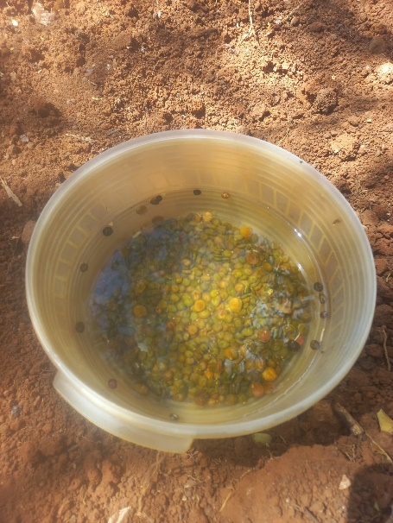 | 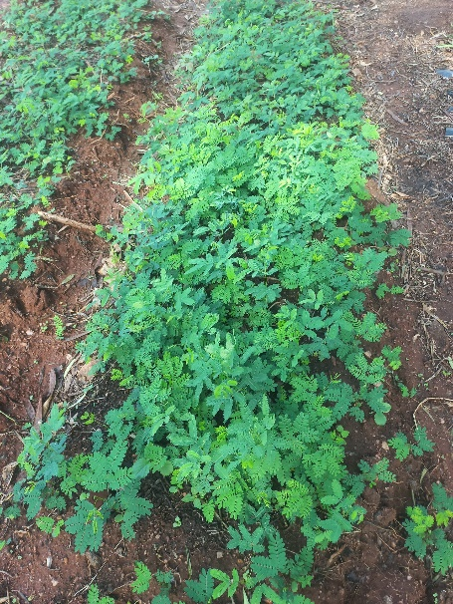
Figure 0-7. Acacia seeds in the in hot water and ready seedlings in raised beds

Other tree species
Our commitment to increasing biodiversity Yahaya has taken lead in selecting potential species for various timber trees, fruit trees, and perennial vegetables for some farmers for simple experimenting. Farmers have added Cordia africana, Grevillea robusta (a valuable timber trees), alongside fruit trees such as guava (from the project), mango, passion, lemon, orange and avocado as farmer own initiative. Additionally, they added 18 cuttings of Morus alba (Mkongea farmer, as requested) to diversify their crops. These initiatives aim to enrich the agricultural landscape and provide a sustainable source of nutrition and income for the farmers. These species are grown in small numbers, as the activity is as much piloting as targeting the fulfilment of the outcome for the beneficiaries.
In February 2025, 3 kg of Cordia seeds was purchased from TFS Lushoto for 125,000tsh. Each farmer received 20 seeds, which were directly sown into polythene tubes and the seedlings planned to be ready for outplanting during short rain October. Some of these seedlings were also outplanted during November short rains while other late germinated seeds will be outplanted in April during long rain of 2025. Outplanted seedlings in 2024 they show good progress although in farms with high dryness (Kwanyange, Ngulu and Kwakoa) seedlings show stunted growth.
In February 2025, 3 kg of Markhamia seeds was procured from TFS Lushoto for 60,000tsh. About 100g of seeds were distributed to each group and initially sown in open beds to encourage germination while some of the seeds sown directly to the polythene bags, in all groups no seeds germinate (the seeds were not viable) and we fail to add the number of Markamia. Currently, some farmers in Kituri and Mkongea managed to grow 3 to 5 seedlings while others left with no seedlings.
In February 2025, we distributed Neem seeds 1 bucket 10L collected locally by youth from Kituri. Each farmer with no Neem tree received and sown 10 seeds to the polythene bags. Germination was about 50% and farmers managed to grow about 3 to 5 seedlings that can be outplanted during short rain in October 2025.
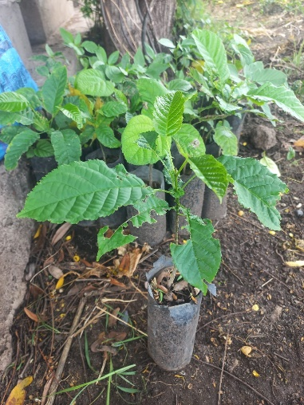 | 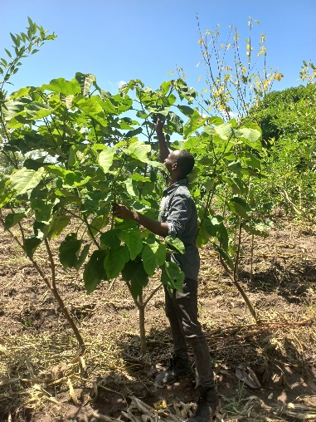 | 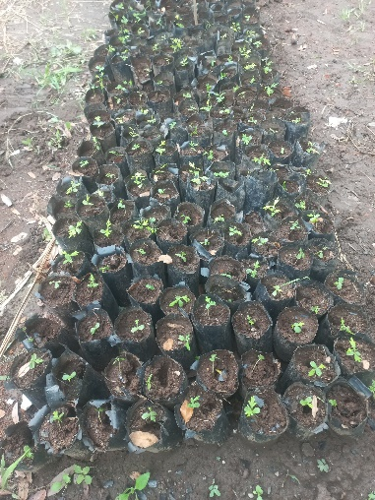
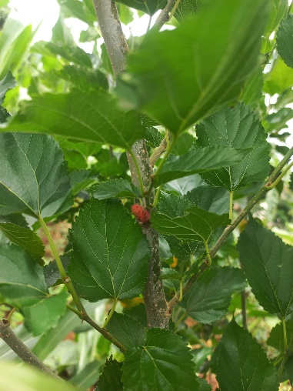 | 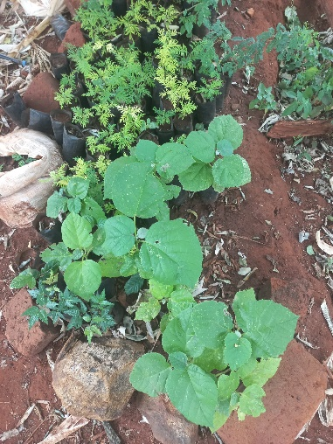 | 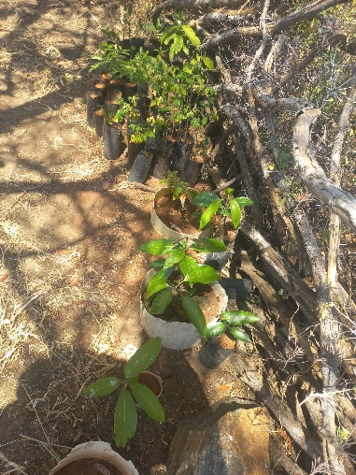
Figure 0-8. Markhamia seedlings, young cordia tree, transplanted grevillea seedlings, Morus alba start bearing fruits, neem seedlings and mango seedlings

Training on organic compost making using Gliricidia, Leucenae, Pigeon pea branches and farm residues.
In March 2025, 369 forest garden farmers learned the production of organic compost. They were equiped with cost-effective, eco-friendly soil fertility enhancement techniques using local resources. The composting method emphasized the use of leaves and pruned branches from Gliricidia, Leucaena, Pigeon pea, and grasses readily available on farm.
Farmers learned the fundamentals of composting, compost as a natural fertilizer made by decomposing plant residues and animal manure and its benefits such as improving soil structure, retaining soil moisture, reducing dependence on synthetic fertilizers, and utilizing on farm waste effectively.
A total of 26 compost piles were established during the practical sessions, with farmers participating in each step. The compost was layered using a 60:40 mix of green (nitrogen rich) and brown (carbon rich) materials, moistened appropriately, and positioned in semi shaded areas to maintain ideal conditions for decomposition. Farmers learned how to construct the piles with correct dimensions, turn the compost every 3-7 days, and monitor internal temperatures using simple stick methods to ensure active decomposition.
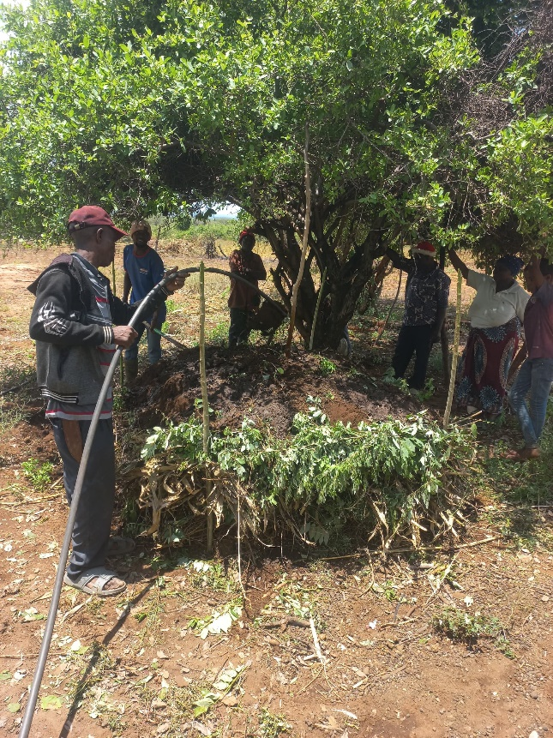 | 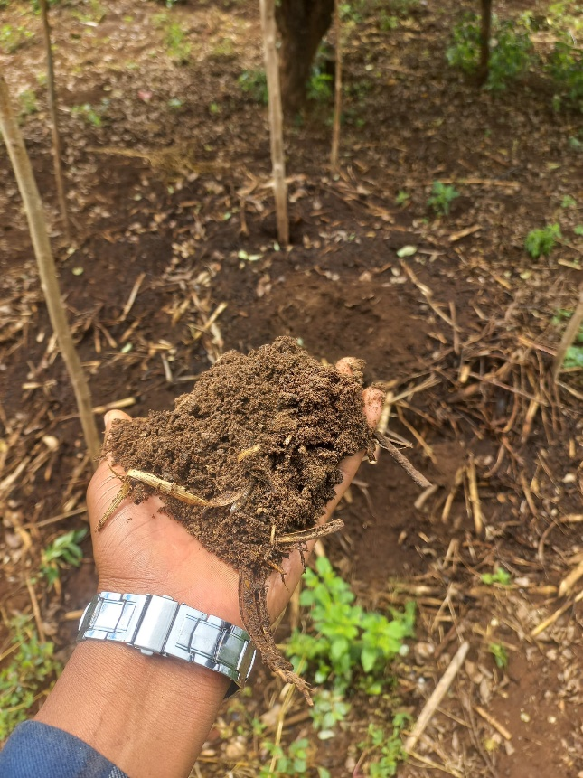
Figure 0-8. Watering compost pile during training and ready compost soil after 7 weeks
Once compost is ready between 6 to 12 weeks the compost was applied to vegetable gardens as a soil amendment and mulch, improving both soil health and crop productivity. It was also used in fruits seedling nurseries and tree planting holes, further integrating regenerative practices within the Forest Garden Model.
To enhance learning and ensure continuity, every participating farmer received a copy of the Swahili-translated composting manual (Mwongozo wa Kutengeneza Mbolea ya Mboji). This resource included simple, illustrated instructions to guide on farm compost production using local materials, ensuring farmers could replicate and teach others in their communities.
This training significantly supported soil health improvement across all participating sites, making organic farming more accessible and effective for smallholder farmers engaged in the Forest Garden project.
Technical instructions of this activity in Swahili can be found in Section 2 of this report.

Outcome 4: Farmers are more knowledgeable, enthusiastic and socially empowered
What activities have contributed towards this outcome?

Accumulative list of all main trainings:
By June 2025, farmers have gained the following knowledge through project activities:
- General knowledge of Forest gardens (design and structure, environmental and human benefits) through weekly facilitation by field staff and extension officers to all farmers. (see below on mapping used for Forest Garden design)
- Nursery establishment and managements includes cutting seedbags, seed collection, potting mix and preparation by hot water treatment (Acacia and Leucaena, Gliricidia direct sowing), sowing seeds in seedbags and raised beds, weeding and watering.
- Growing fruit and timber trees.
- Growing and replanting cassava and sweet potatoes
- Understanding basics of the importance of nutritional diversification (several colours needed, and aiming at growing roots, leaves and fruits)
- Outplanting seedlings with specific patterns including live fence, fruit and timber trees.
- Maize planting technique, with Pigeon pea as pure crop or marejea (alleys).
- Organising collective activities including compost making using Gliricidia, Leucaena, pigeon pea branches and timely meeting schedules.
- Harvesting papaya, passion fruits and vegetables.
- Other practical trainings delivered in farmer groups have included organic pesticides made of Neem and boosters we use manure tea and plant tea. (See section 2 for a lesson handout on organic pest management)
- Crop rotation training to all groups, June 2025 (See section 2 for a lesson handout on crop rotation)

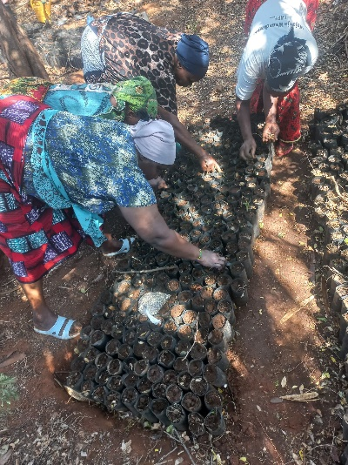 | 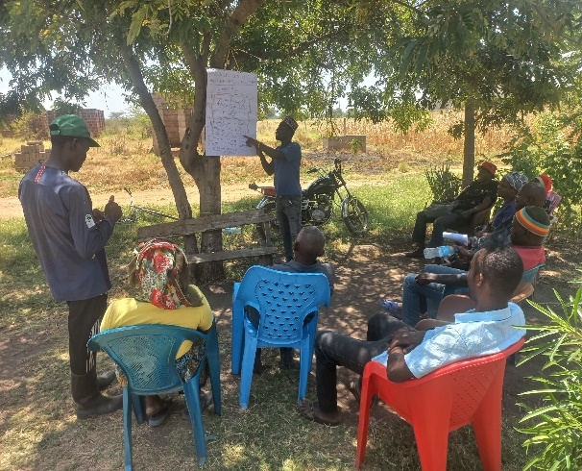 | 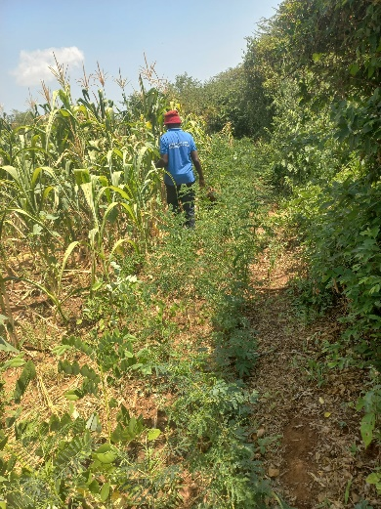
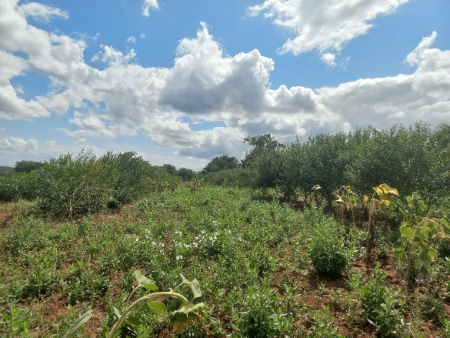 | 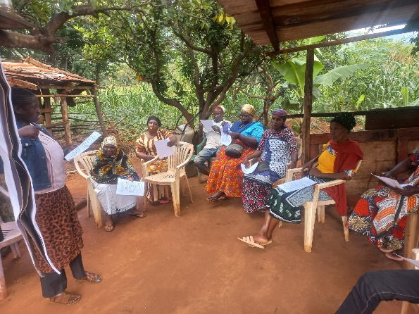 | 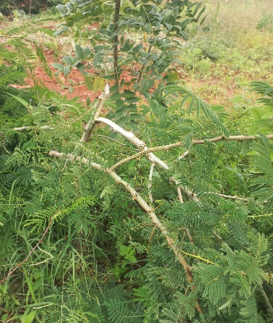
Figure 0-9. Timber tree nursery establishment, weekly facilitation, established live fence, health pigeon pea marejea, crop rotation training, and weaving of acacia live fence.

Participatory mapping and tree planting layout training for Forest Gardens
As the initial mapping exercises with the old groups in early 2023 were found to be very challenging, the same was tried again with all groups, however, with a simpler concept, using sketching rather than mapping in scale. In March 2025, farmers learned to use Participatory Mapping and Tree Planting Layout Planning in Forest Gardens. The sessions aimed to empower farmers with practical skills in designing effective planting layouts for fruit and timber trees, tailored to their unique land sizes and species choices.
A key outcome of the training was the development of 26 demonstration sketch maps, each showing the arrangement of live fences, fruit trees, timber species, and food crop zones. These maps were submitted to the group representative and will remain available for reference and farmers feedback throughout the implementation phase.
The training built on previous sessions on nursery establishment and compost making, marking a crucial step in transitioning from seedling preparation to field layout and planting.
Key training elements:
- Design principles: Farmers learned how to map their plots using sustainable agroforestry principles, with attention to light, soil fertility, biodiversity, and intercropping benefits.
- Wind break: Grevillea robusta was selected for boundary planting at 3-meter intervals, offering wind protection and future timber and firewood value.
- Fruit trees: Mapped within the interior and edges of the garden, species such as avocado, mango, lemon, guava, jackfruit, and papaya were spaced based on growth needs (4x4 to 6x6 meters).
- Timber trees: Markhamia lutea, Cordia africana, and additional Grevillea trees were included in strategic positions for both ecological and economic value (6x6 or 15x15 meter spacing).
- Map preparation: Each farmer created a detailed sketch showing zones for different tree categories and food crops, along with total seedlings, planting dates, and expected outcomes.
In addition to mapping, the sessions included maintenance of Forest Gardens:
- Tree care: Guidance was provided on mulching, watering (3 times/week in dry seasons), pruning, pest control using natural remedies, and livestock protection.
- Hands on planting: Farmers practiced measuring distances and planting based on their sketches, supported by facilitators who verified layout accuracy.
- Reflection and feedback: Farmers shared their experiences and challenges, allowing facilitators to offer tailored advice and farmer to farmer learning.
This training advanced the forest garden implementation and strengthened farmers' planning capacity and ownership of their agroecological systems. The submission of sketch maps sets a clear pathway for ongoing monitoring, revision, and group-based learning as the planting season progresses.

Outcome 5: Local NGOs capacity has been built in FGs approach and communications
What activities have contributed towards this outcome?
- All Trees for the Future training materials have been given in the use of all staff and extension officers. Sections have been distributed in WhatsApp group and email, relevant chapter at a time for self-study before trainings.
- Team work for planning, implementation and assessment of all activities naturally enhances the professional capacity of everyone involved. Thus, for learning purposes, we openly share ideas, successes and challenges within the whole team (the field staff, extension representative and Liana).
- In February 2025, KIMAS visited Mwanga District, Kilimanjaro Region, where representatives including farmers, staff, and extension officers engaged in a study tour to learn from established Forest Garden projects. During visits to seven farmers in Kituri A, Kituri C, Kalimani, Mapambano and Kitopeni groups, participants observed practical applications of key techniques such as live fencing, multi-cropping, mulching, and composting. The strong commitment and clear benefits demonstrated by Forest Garden farmers emphasized the importance of dedication, hard work, and individual responsibility in successfully managing Forest Gardens. Motivated by the visit, all participating farmers expressed great enthusiasm and committed to immediately applying the knowledge and practices gained within their own communities.
- In March, 80,000Tsh from the project fund was used to purchase a notice board for the Forest Garden office. The board serves to inform staff and visitors about the organization’s structure, principles, and work ethics. It also displays the project daily timetable, the names of Forest Garden groups and their villages, as well as the facilitators responsible for each group. It also showcases photos of Forest Garden farms and activities, helping to create greater awareness and motivation among the team and visitors.
- End of March 2025, Rodrick, a trained horticulturalist on his way to work for the Masasi Forest Garden project visited Mwanga. He showed strong enthusiasm to learn, actively engaged with the team and farmers, and shared practical composting tips in Kwanyange groups. Despite the short visit, he learned a lot especially concerning the agroforestry side, and adapted quickly. He also visited Eliya’s farm in Kituri to understand a complete Forest Garden setup, learning about tree integration, and taking photos for reference.
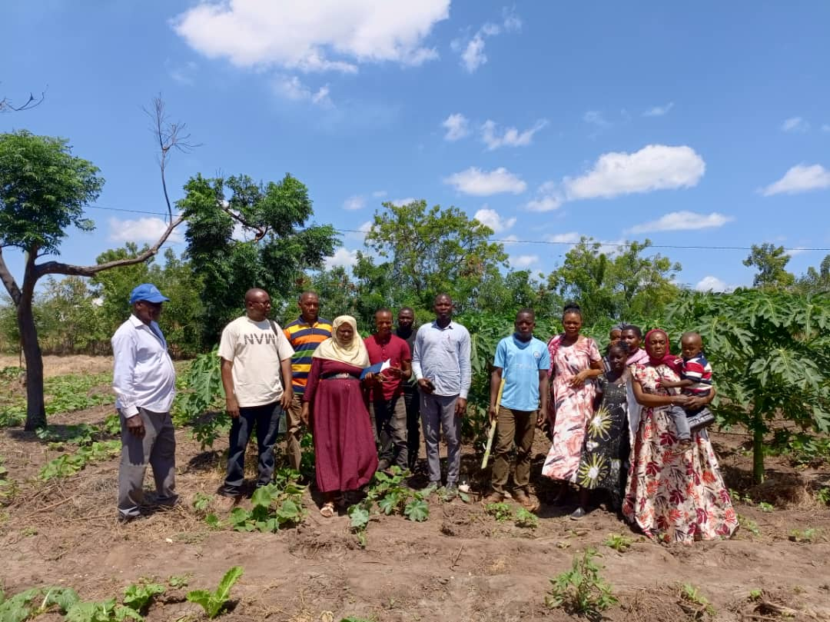 | 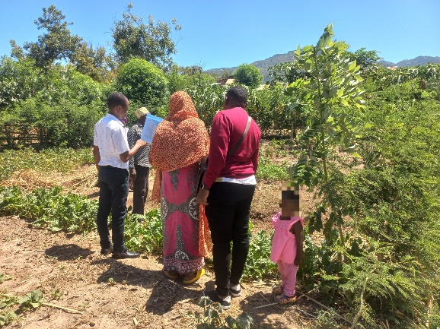
Figure 0-10. KIMAS and KIWAMWAKU internal auditor visit to forest gardens

Project outputs

Output 1: Government officers and villagers engaged
What demonstrates this?
The full participation of extension officers in all project activities clearly demonstrates the close collaboration between the project and the local government. Local authorities remain closely engaged with project activities, as each group is visited weekly by the project staff and extension officers. In Kwanyange A group, the village chairperson is also a member of the Forest Garden group.

Output 2: New version: Forest Garden groups functioning (as many groups as needed to reach the minimum target number of farmers, 350)
How much has been achieved by now?
Currently, we have a total of 26 active farmer groups with a total of 367 farmers, among whom there are 191 women and 176 men. From this groups, six are old groups, with a total of 53 farmers (Fe 29 and Me 24), and 20 are new groups, with a total of 314 farmers (Fe 162 and Me 152).
Special attention was also paid to having a minimum of 10% PLHA in groups. With confidential collection of data, we have established that there were 9 such members in the old groups in 2023, and 12 members belonging to this vulnerable group in the new groups in 2024.
The old and new groups are both functioning effectively, as shown by the absence of drop-outs in the old groups and high attendance rates across both. Farmers who miss meetings still receive updates from others, ensuring continuous engagement.
VICOBA groups are steadily progressing by reinvesting their money through internal loans among members. Furthermore, sweet potato cultivation is flourishing among the new farmers while pigeon pea cultivated by all groups, reflecting consistent growth and success in their agricultural activities. Vegetable growing have been very motivating to farmers, thus we also supported group-based cultivation in 11 farmer groups in the dryest villages.
For a full list of components added so far in the Forest Gardens (demonstrating functioning groups), see below under Output 5.
Well written rules for groups has been the first step in making groups function and to safeguard good code of conduct. Thus the new groups were helped to get good constitutions in December 2023 and at the beginning of the year 2024.
So far, we can assess the 'functioning' of groups by
- Counting the number of live trees (see under Outcomes for live fence and other tree growing)
- By monitoring group attendance levels in 'harambee meetings' (scheduled weekly meetings for discussion, organization, training, and collaborative work).
- Retaining rate or drop-out level
- Number of farmers who have the following crops growing in the farms: Papaya trees, Cassava, Pigeon peas, Sweet potatoes, Vegetables, Passions and Timber trees
- Establishment and use of compost

Output 3: New version: Representative of each group, and minimum of 4 extension officers trained
How much has been achieved by now?
Facilitators all need to use knowledge and skills gained to raise levels of self-motivation to other farmers to fully participate in project activities as planned.
Among the 26 groups, each group has nominated their leaders. These may not be the same as the administrative leaders of the groups (chair, secretary and treasurer).
On 24 January 2025, Yahaya and Eija conducted a full-day Trainer of Trainers (ToT) session for project staff and five extension officers. Yahaya’s training focused on facilitation principles and the power of effective facilitation learned from SAT training. It emphasized the importance of thorough preparation before facilitation sessions and encouraged facilitators to put farmers at the center of learning. Eija’s short session was about solution-focused approaches. As a result of this training, a facilitation rotation system was introduced and since then followed, facilitation handouts have been developed and shared for each lesson, and extension officers became more actively engaged by sharing pictures and messages through WhatsApp groups.
Table 2 Number of extension officers attended Trainer of Trainers training at KIWAMWAKU 24th January 2025
NAME | VILLAGE/GROUP
REHEMA BASHEMELA | KISANGARA & KIRURU IBWAIJEWA
BURUHANI | KISANGARA, NGULU & KWAKOA
LYDIA MKENI | KITURI & KIRURU IBWAIJEWA
RAHEL | KIFARU
MICHAEL KIMARO | SENIOR EXTENSION

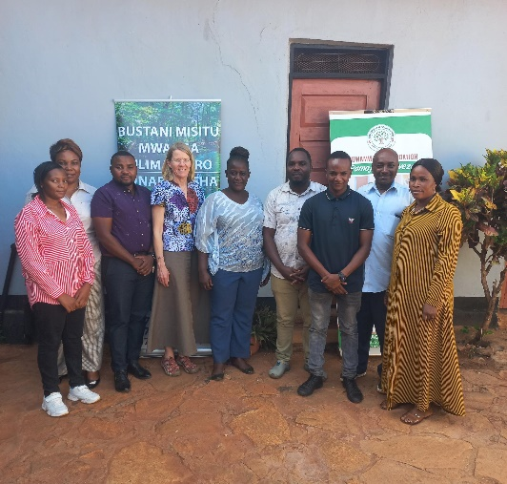 | 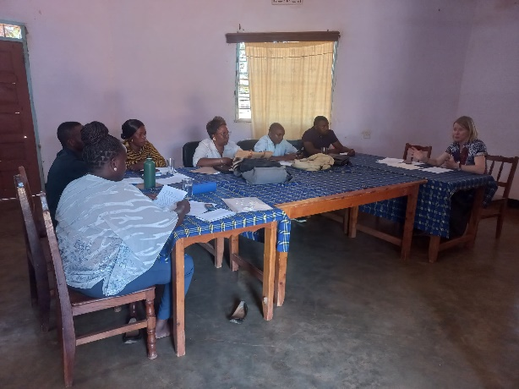
Figure 1-7. KIWAMWAKU staffs, extension officers and Eija during and after ToT session
The agricultural extension officers played a key role in supporting farmers during and after the weekly facilitation sessions, ensuring that the knowledge gained was effectively applied on their farms. The training significantly improved the facilitation skills of the extension officers, enabling them to engage farmers more actively and deliver technical content more effectively.

Output 4: New version: Members trained in selected training sites
See all training topics for year 2024 under Outcome 4.

Output 5: 360 individual farmers' Forest Gardens established
How much has been achieved by now?
Currently, we have successfully completed the live fence, all four sides for most old members and new members. Others have planted up to three sides. Within the scope, all members have added basic components including:
- Live fence using Acacia, Gliricidia, and Leucaena species.
- Fruit trees such as papaya, guava, passion fruit, lemon, and avocado.
- Timber trees including Markhamia lutea and Cordia africana, which have been added by all group farmers.
- Vegetables such as Telfairia pedata, perennial leafy greens like cassava leaves, comfrey, and Moringa oleifera.
- Food crops such as cassava, pigeon pea, and sweet potatoes.
- Composting sites, established to improve soil fertility.
These achievements can be verified through field facilitator reports and direct visits to the established gardens. While not all components are fully established by every member, the progress demonstrates the collective commitment of the group to building resilient, diverse, and productive Forest Gardens.

Output 6: 1080 Neighbouring farmers trained/recruited by group members
How much has been achieved by now?
From January, we started inviting and recruiting neighbors from all groups, with the target of having each farmer recruit three neighbors whom they could train and follow up with regularly. During the training sessions held from February, more than 500 neighbors were reported to have joined; however, many were not consistently active throughout all sessions. Despite this, we managed to track approximately 300 neighbors who actively engaged in the activities and successfully established about 63 meters of live fences on their farms. (See more details in Outcome 3 above.)

Output 7: Savings and Loans function started, Marketing Associations established
How much has been achieved by now?
In January 2025, new farmers learned the concept of Village Community Banking (VICOBA). The training covered key aspects including VICOBA principles, savings, loan processes, and group accountability. The primary goal was to empower farmers with the knowledge and financial skills necessary to manage their resources effectively, enhance their livelihoods, and strengthen financial resilience.
To ensure the smooth and secure operation of each VICOBA group, each group received essential materials and tools, including a cash box, two passbooks per farmer, an ink pad, stamp pad, ledger book, seal stamp, and three locks (each held by different group members to ensure transparency and security). Farmers were encouraged to mobilize savings from various sources such as the sale of vegetables, fruits, and other farm produce, and to contribute part of their income to their VICOBA groups for collective financial growth and future investments. Each group also developed and adopted its own constitution to guide operations and governance and the project supported the formal registration of twenty new VICOBA groups at the District Office, securing their legal recognition by the government.
The total cost incurred for procuring VICOBA materials and completing the registration process amounted to 3,762,000Tsh. (see a breakdown of the activity budget in Section 2)
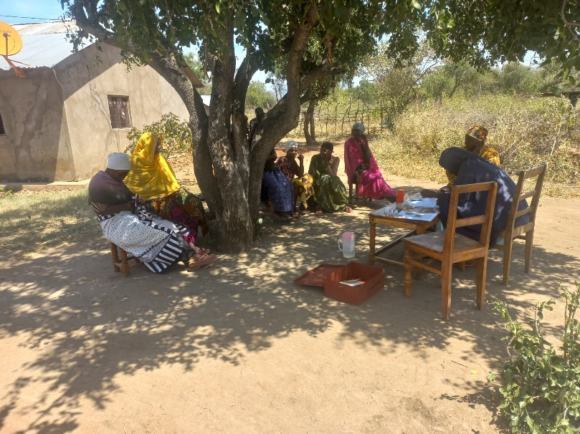 | 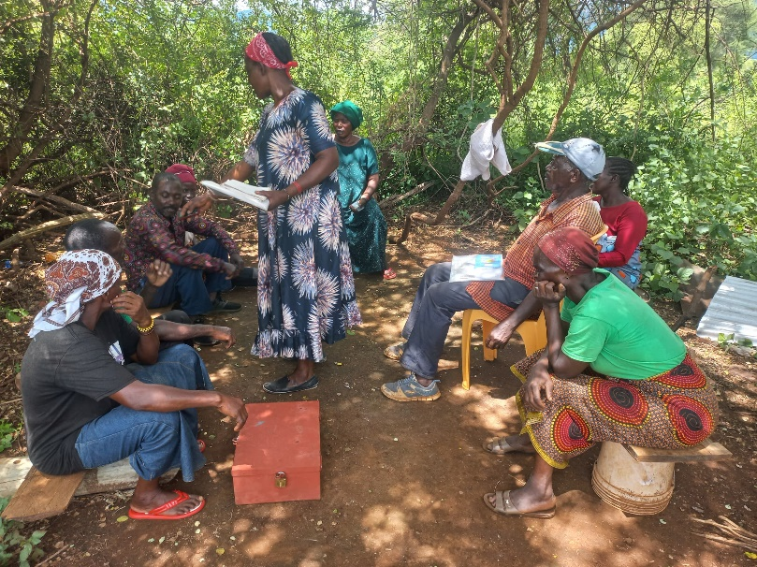
Figure 0-1. Nyata and Kwanyange groups in VICOBA session

Output 8: Local NGOs have participated to raise its capacity in FGs
Please see under Outcome 5.

Other happenings and activities

Staff changes and Internship
In June, Sarah, with BSc in Agricultural economics, joined the Forest Garden Project team as an intern and assistant field facilitator for a three-month period. She stepped in after Julius got a government job and handed over his responsibilities. Although efforts to recruit a staff member with horticulture experience were not successful, Sarah was ready and eager to seize the opportunity to learn through an internship. To support her role, she also participated in basic organic agriculture training to strengthen her facilitation skills.

KIWAMWAKU internal auditor visit
In February 2025, the internal auditor, Mr. Amani, visited Kisangara groups during the delivery of VICOBA materials to farmers. He observed the facilitation process and overall project progress, ensuring proper distribution and engagement with group members. Mr. Amani also took the opportunity to ask farmers about the delivery and use of vegetable seeds, tree seeds, and other materials provided by the project.

CRDB bank group account explanation
In June, a representative from CRDB Bank conducted a session with the farmer groups and explain the benefits of opening a bank account, which is offered without monthly charges. He emphasized that having a formal account provides a safe and secure option for managing group funds, particularly when the amounts become substantial. It also help maintaining accurate financial record keeping, which can enhance transparency and strengthen trust among group members. The decision remain to farmer themselves to choose whether to open it or not.

Financial Report of January to June, 2025
